**Milan Zadafiya**

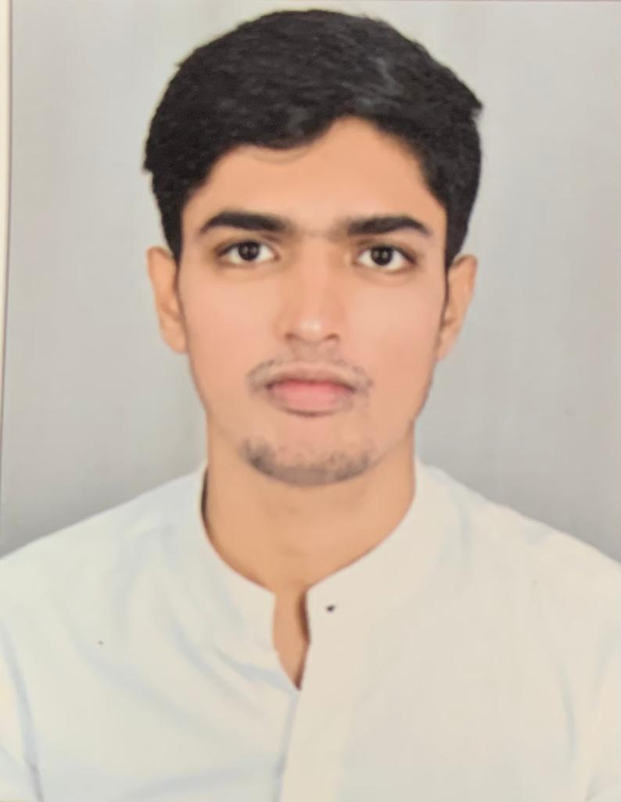

**59th Vandana soc,div-1,**

**Nana varachha,Surat-395006**

**Email:-** [**milanzadafiya.1@gmail.com**](mailto:milanzadafiya.1@gmail.com)

**Phone No:-9998903295**

**OBJECTIVES**

To become an integral part of a professionally managed reputed Organisation ,to utilize my administration and managing skills for a mutual growth

**PROFILE**

* I am reliable hard working and well organized man with mature decision making capabilities.
* Have excellent communication skills in English & Hindi
* Can achive organizational goals by building an effective team
* Initiative, Leadership Qualities and Co-operative
* Good Communication Skills and Hard Working
* Quick Learner,ability to think positive and face challenges

**ACADEMIC PERFORMANCE**

|  |  |  |  |  |
| --- | --- | --- | --- | --- |
| **Qualification** | **University/Board** | **Institution** | **.Percentage** | **Year of passing** |
| **10TH** | *Gandhinagar* | *GSEB* | *67.50%* | *2014* |
| **12TH** | *Gandhinagar* | *GSHEB* | *78.14%* | *2016* |
| **B.COM** | *Surat* | *VNSGU* | *55.90%* | *2020* |

**TECHNICAL SKILLS**

Having proficiency in Accounts,Banking.

**PERSONAL DETAILS**

**Date of Birth :** 17th June 1999

**Nationality :** Indian

**Status :** Single

**Languages Known :** English,Hindi

**Father Name :** Sanjaybhai

**Mother Name :** Muktaben

**I hereby confirm that all the information furnished above is true and correct. I shall show sincerity and dedication in my work,which will prove to be honest and hard word**

**DATE:**

**PLACE:**

**(*Milan Zadafiya*)**